
PERIODIC TEST 1(2023-24)
ANSWER KEY
Subject: Marketing  Grade: 12 |  | Max. Marks:35  Time:1hr min
Name: |  |  | Section: | Roll No:
- General Instructions:
- Attempt all parts of a question together

 | SECTION A (1X5=5 MARKS)
 | c. Brand name |  |  |  |  | 1
2. | c. Packaging |  |  |  |  | 1
3. | c. Non-durable goods |  |  |  |  | 1
4. | b. Augmented |  |  |  |  | 1
5. | d. Dominant, increasing |  |  |  |  | 1
 | SECTION B (2X5=10 MARKS)
6. | PRODUCT LINE is a group of products that are closely related, either because they function in a similar manner or are sold to the same customer groups or are marketed through the same types of outlets, or fall within given price ranges. Many businesses offer a range of product lines which may be unique to a single organization or may be common across the industry. Eg. "Accident, health and medical insurance premiums" and "income from secured consumer loans." within the insurance industry, product lines are indicated by the type of risk coverage, such as auto insurance, commercial insurance, and life insurance |  |  |  |  | 2
7. | MARKETING STRATEGY OF SHOPPING GOODS: (a) Price: These goods are available at moderate prices. The seller must apprise the buyer with the price. (b) Promotion: Heavy advertising and personal selling by both producers and resellers. (c) Place: As consumers will spend time to shop for these goods, stores that specialize in them are located near similar stores in active shopping areas. (d) Products: Furniture, clothes, used cars, etc… |  |  |  |  | 2
8. | MARKETING STRATEGIES IN DECLINE STAGE 1. The product can be maintained by either by adding new features or finding new uses. 2. The costs can be reduced and it can be offered to loyal segment. 3. The product can be discontinued or sold to another firm that is willing to continue the product. |  |  |  |  | 2
9. | Regularly Unsought Products: The products which exist but the consumers do not want to purchase them as of now, but might eventually purchase them. Example: Life Insurance Products or Doctor’s services. New Unsought Products: The marketers task is to inform target consumers of the existence of the product, stimulate demand and persuade then to buy the product. Example: Oral Polio Vaccine was unsought initially, but heavy promotion and persuasion by the government has lead to eradication of polio. |  |  |  |  | 2
10. | Ownership:  a) Manufacturer’s brand: When the ownership lies with the manufacturer and the producer provides the brand name to the products, it is called manufacture’s brand. The manufacturer is responsible for its marketing and enhance customer loyalty by building the brand name. Examples include Apple, GE, Intel and McDonald’s. b) Middleman’s brand/ Store brand/Private label: In certain cases, the manufacturers do not undertake branding by themselves, instead they leave their products to the wholesalers or retail chains for the branding, these brands are named as Middleman’s brands/ Store brand/ Private Labels. Example include Reliance Select a brand of Reliance Retail |  |  |  |  | 2
 | SECTION C (3X4=12 MARKS)
11. | Maturity stage  The characteristics of this stage are • Costs would be decreased as a result of increase in production volumes • The Sales volumes peak and market saturation is visible. • Competitors entering the market increase • There is drop in prices due to entry of competing products • Advertising spend incurred on brand differentiation |  |  |  |  | 3
12. | PRODUCT DIVERSIFICATION: Product Diversification refers to the product expansion either in the depth and/or in width. Depth of product-line implies the assortment of colors, sizes, designs, quality, stability, etc. It refers to adding a new product to the existing product line or mix. e.g. - Godrej Company used to manufacture cupboards, locks, safes, refrigerators etc. on a large scale but has now diversified into cosmetics, soaps etc ¬ PRODUCT MODIFICATION: Product modification may be defined as a deliberate alteration in the physical attributes of a product or its packaging. It is the process by which the existing products are modified to suit the changing demand on account of changes. E.g.: Television manufacturers are bringing out certain modifications in order to suit the changing demand |  |  |  |  | 3
13. | QUALITIES OF GOOD PACKAGING • Attractive appearance • Convenient for storage and display • Shield against damage or pilferage • Product description displayed on the package • Package should be as per the specifications |  |  |  |  | 3
14. | 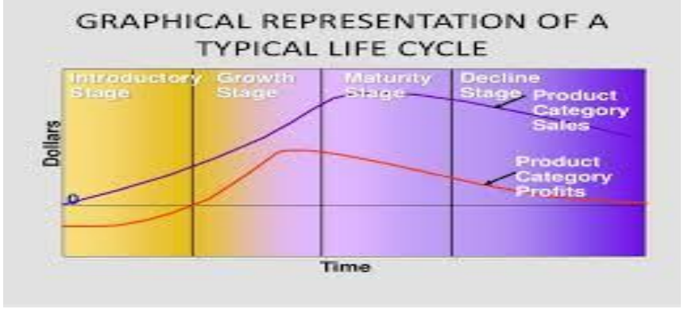  Introduction Stage In this stage a new product (from brand or category) is introduced and it is called the introductory stage. Introducing a new product is always a risky proposition, even for a skillful marketer. A new product category requires a long introductory period because primary demand ie demand for the product category must be aroused. Ex. When “Allout” in 1990 introduced liquid vaporizers as mosquito repellent, it was a pioneer in the product category as till 1990 mosquito coils were prevalent. |  |  |  |  | 3
 | SECTION D (4X2=8 MARKS)
15. | Industrial products  Types of Industrial Products: (i) Materials and Parts: These are goods that are used for manufacturing the product. These are further divided into two types: (a) Raw Material: The raw materials could be either agri based products like sugar cane, rubber. Wheat etc or they can natural products like iron ore, crude petroleum etc. Farm products are renewable as they involve agricultural production. The natural products are very often limited and often available in great bulk and low unit value. There are a few but large producers and marketers supplying natural products. Long term supply contracts are a common phenomenon in these categories, as the industry needs an uninterrupted supply of products and services for running their business process. (b) Manufactured Materials and Parts: These include component materials like glass, iron, plastic or components like battery, bulbs or steering etc. The component materials are further fabricated from aluminum, pig iron to steel and cloth from yarn. Components enter the final product without being changed or modified. In this case price, quality and services are important factors while making a decision. (i) Capital Items: They are the goods used in producing the finished goods. They include tools, machines, computers etc. They can be categorized into installations like lifts, mainframe computers etc and equipment’s like fax machines, EPBX machines. Installations are major purchase for the organization. Equipment’s include hand tools and office equipment’s like personal computers, laptops. These equipment’s are not everlasting and they need to be refilled at different periods of time. (ii) Supplies and Business Services: They are goods which are required for developing or managing the finished products. They can be of two kinds namely maintenance and repair items and operating supplies. Maintenance supplies include painting, nailing and operating supplies include writing papers, consumables for computer, lubricants and coal. Business services can be classified as maintenance service like copier repair, window and glass cleaning and business advisory services include consultancy, advertising and legal services |  |  |  |  | 4
16. | Types of Packages There are four types of packages: (i) A consumer package (ii) a bulk package, (iii) an industrial , and (iv) a dual usage package. They are as discussed. (1) A consumer package is one which holds the required volume of a product for ultimate consumption is economical and can be easily purchased by the consumer. He has the option to purchase the pack size which he considers adequate for the consumption for his family over a length of time and does not involve additional investment during that period. (2) A bulk package is either for the consumer whose consumption is large or is bought to save cost. Example: oil cans etc. The consumer package itself very often requires an outside package in which it is transported and which is sometimes referred to as transit package or an out container. (3) An industrial package can be a bulk package for durable consumer goods. These are the basic package types although many sub-divisions can be listed, e.g., strip package, multiple package, etc., which can all be broadly listed under these basic headings. (4) A dual use package is one which possesses a secondary usefulness after its contents have been consumed. Drinking glasses, boxes of jewellery or cigarettes, plastic containers, refrigerator dishes, bags from flour and feed sacks are the examples. |  |  |  |  | 4

